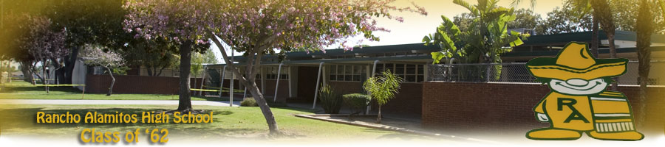
March 2016
Dear RAHS62 Classmates,
Along with several of our classmates, I have been considering ideas for a possible 55th Reunion in September 2017. Age is creeping up on each of us, so perhaps a big reunion (like our 50th) may be less attractive now than a simple, casual and low-cost one.
Please reply to either me or Jan Tonner with your level of interest in each of four 55th reunion options using the following scale: 0 = no interest, 1 = possible interest, 2 = likely interest, and 3 = strong interest (“I’ll definitely be there”).

 | RAHS62 2017 Reunion Options | My vote (0, 1, 2 or 3)
A | A mid-week afternoon picnic in a park (such as the beautiful Lantern Bay Park in Dana Point, California)
B | A mid-week luncheon and program in a hotel or restaurant near Dana Point
C | Dance and refreshments in the evening
D | All of the above

Please let us know if you have (1) other ideas for our 55th Reunion or (2) comments on our proposed September 2017 date and place. We appreciate your suggestions.
I look forward to seeing each of you again, either individually or at a Reunion.
With best wishes, Barrie Smith, Tel: 208-859-0475, Email: jsbv955@gmail.com
Alternatively, please respond to Jan Tonner via email at: jrt@tonner.org

RAHS Classmate name: __________________________ Home phone: ________________
Mobile phone: ________________ Email: ______________________________________
Postal address: ___________________________________________________________
I would like to be a member of the RAHS62 55th reunion planning committee: Yes No
Additional comments: _______________________________________________________

